Golden Foot Walking Awards 2024 Nominations
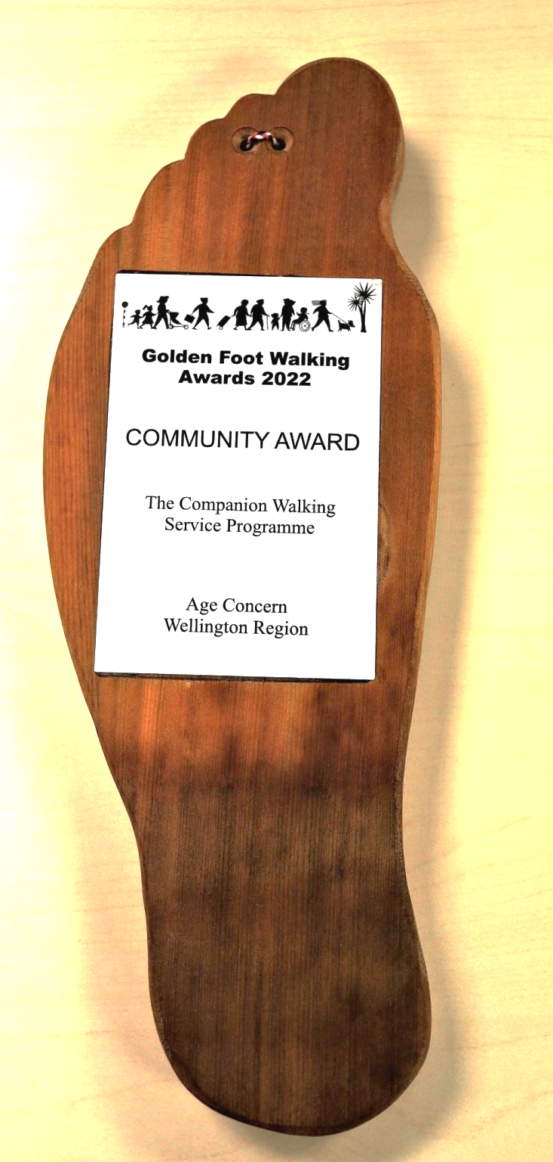
The Golden Foot Walking Awards celebrate and recognise New Zealand achievements for walkers. The Awards acknowledge innovative new facilities, highlight national best practice and reward the ongoing commitment to walking and pedestrians.
The Awards are available to private companies and public organisations, not-for-profit groups, community organisations and individuals.
Entries must be received by Monday 17 June 2024.

Golden Foot Walking Award nominations for 2024 can be about:
- Projects and programmes
- Facilities or place-making
- Events
- Research
- School projects
- Walking Advocate Champions
- Extraordinary walkers (e.g. walkers completing the Te Araroa Trail in record times or ways, walk fundraising for a particular cause, commuters walking long distances or overcoming barriers, stories of health gains through walking)
- Walking and Public Transport initiatives
- Buildings and public spaces that demonstrate strong accessibility and CPTED principles
Please note: Walkers means pedestrians – those on foot or using a wheelchair. Shared path projects are not eligible.
All nominations are valid if they have not been previously entered into the Golden Foot Walking Awards. See examples of previous years’ successful nominations.
The Awards Ceremony will be held in July (details to be advised).

Important information
The closing date for entries is Monday 17 June 2024.
Criteria for judging entries
The judges will be considering:
- How well the project or individual encourages or facilitates others to walk
- How well the project or facility overcomes barriers to enable more walking
- Accessibility
- Whether the NZ Pedestrian Network Guidance and other appropriate standards have been considered in the planning and implementation of each nomination.
Correspondence
The completed nomination should be emailed to: goldenfoot@livingstreets.org.nz. One nomination per email please.
For any queries, please contact the Awards Coordinator.

Points to note
- All nominations must be in relation to a New Zealand walking project.
- The maximum entry size is a document of five A4 pages as a DOC, PDF, DOCX, RTF file format.
Any information beyond the five page limit will not be evaluated.
- Please also attach a high resolution photo in standard formats (JPEG, PNG, PDF or GIF) of the project and any maps produced. If files exceed a 6 MB limit, please send in separate emails with identical subject headings.
- Please send a high-resolution logo of the nominated organisation or photo of the nominated person. If these are not easily available, please be prepared to obtain these upon request.
- Entries may include web links, but please note that these will only be referred to at judges’ discretion.
- Although the judging panel may independently seek additional information on nominated entries, it is in your best interests to provide as much detail in your entry within the five pages.
- If alternative material/media is considered important as part of the submission, please contact the Awards Coordinator as early as possible.
- The Awards Coordinator reserves the right to determine the appropriate Award Category for
a nomination.

Please enter using this form

Your contact details
First Name:
Last name:
Organisation:
Email:
Telephone:
Your relationship to nominee:
How did you find out about the Golden Foot Walking Awards? (please circle one)
Letter / Email / Living Streets Aotearoa website / Twitter / Facebook / other (please specify)

Nomination details
Note: Where multiple agencies were involved in the project, ONE main organisation should be specifically nominated for the award (although others should be acknowledged).
Name of project:
Address of project:
Name of organisation/s:
Contact person name:
Email:
Telephone:

Summary about the nomination
As part of your nomination entry, please provide a 50-word summary description. (This will be used for subsequent publicity and as an abstract for the Awards ceremony.)

What to include in your nomination document:
In the main body of the nomination, these are the things to consider covering:
- What motivated this initiative? What barriers were overcome and who was involved in the initiative?
- Coverage in terms of number of people affected, geography, and demography for this initiative.
- Success to date of the initiative to encourage walking and meet its objectives, include some detail on funding for the project.
- Potential applicability of initiative to other locations or organisations.
- Relative uniqueness and innovation of this initiative in New Zealand.
Please provide any additional supporting information that may be helpful for comprehension and subsequent publicity, up to the 5 A4 page document limit.

Send us your nomination:
The completed nomination should be emailed to goldenfoot@livingstreets.org.nz
(one nomination per email please). Closing date is Monday 17 June 2024.
Checklist
All form fields filled out.
50-word summary filled out.
Nomination document included – up to five A4 pages.
Supporting photos included.
Logo or nominated person’s photo included.
Email your nomination to goldenfoot@livingstreets.org.nz

Thank you for nominating.
There will be an opportunity for finalists to showcase their nomination at the Award ceremony.
Your nomination will be added to our database of examples of great New Zealand walking projects.
We look forward to celebrating your successes.

