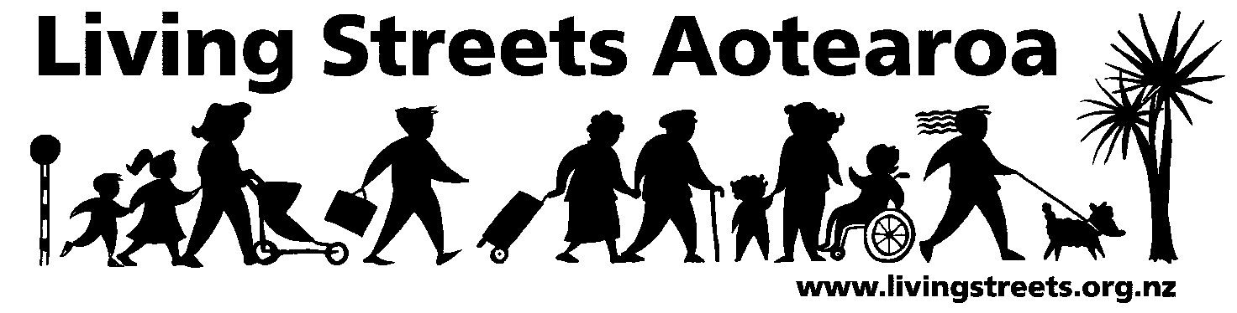
Submission on Proposed Land Transport (Road User) Amendment Rule

Contact person: Mike Mellor mike.mellor@livingstreets.org.nz
Phone: 027 684 1213
Date: 24 June 2011

About Living Streets

Living Streets Aotearoa is New Zealand’s national walking and pedestrian organisation, providing a positive voice for people on foot. We work to promote walking friendly planning and development around the country. Our vision is “More people choosing to walk more often and enjoying public places”.

The objectives of Living Streets Aotearoa are:
- to promote walking as a healthy, environmentally-friendly and universal means of transport and recreation
- to promote the social and economic benefits of pedestrian-friendly communities
- to work for improved access and conditions for walkers, pedestrians and runners including walking surfaces, traffic flows, speed and safety
- to advocate for greater representation of pedestrian concerns in national, regional and urban land use and transport planning.

Our Submission

Give-way rules
Left turn v. right turn priority
Proposal 1. It is proposed to amend the Rule to require a driver when turning right at an intersection to give way to all oncoming traffic travelling straight ahead or turning left, unless a traffic sign or traffic signal requires the driver to stop or give way.
Uncontrolled T-intersections
Proposal 2. It is proposed to amend the Rule to require all traffic from a terminating road at an uncontrolled intersection to give way to all traffic travelling on a continuing road.

We support both these proposals for all the reasons given in the consultation documentation. We note that these reasons include increased safety for pedestrians, and consistency with other administrations, particularly Australia.

While the proposals would result in improvements in both these aspects, they would still leave an inconsistency in a significant area, which, if addressed, would further improve safety. The inconsistency is that in Australia drivers turning at any intersection (except a roundabout) must give way to any pedestrians crossing the road they are entering.

As in Australia, we submit that this should also apply where traffic is controlled by a traffic sign or traffic signals, and to driveways. As the Overview notes, “greater uniformity with other jurisdictions would produce safety gains as drivers from overseas would not have to adopt different give-way rules from those in their own countries”.

In terms of the application of rule-making criteria, we submit that our modification is not significantly different from the rule proposals, except that the achievement of strategic transport objectives would be enhanced by further improving safety; that benefits would be increased and costs would be largely unchanged (from observation in Australia, additional delays to vehicles giving way would be minimal); and the greater consistency with Australia would be a positive example of the adoption of best practice from an overseas jurisdiction.

The Problem Definition in the Appendix to the Overview notes the increasing level of crashes at intersections involving pedestrians, many being hit by turning vehicles when crossing the road that the vehicle is turning into. We submit that the simplicity of our proposal, based on Australian experience, would clarify responsibilities in this area, reducing confusion and thereby increasing safety.

The benefits identified in the Appendix include the alignment of New Zealand rules with those of other countries, making it easier for international tourists driving in New Zealand. As proposed, the alignment is incomplete: increasing this alignment in accordance with our submission would further increase this benefit.

In terms of costs, we see no significant increase required to the extensive publicity and education campaign already proposed, and the table of financial implications of the proposed change to give-way rules would be unchanged, with the safety and consistency benefits improving the already-high benefit/cost ratio.

If there is an opportunity, we would like to be heard in support of this submission.

See for example http://www.vicroads.vic.gov.au/Home/SafetyAndRules/RoadRules/Pedestrians.htm, specifically rules: 38 Giving way when making a U-turn; 67 Stopping and giving way at a stop sign or stop line at an intersection without traffic lights; 69 Giving way at a give way sign or give way line at an intersection (except a roundabout); 71 Giving way at a give way sign or give way line at other places; 74 Giving way when entering a road from a road related area or adjacent land; 75 Giving way when entering a road related area or adjacent land from a road, online at http://www.legislation.vic.gov.au/Domino/Web_Notes/LDMS/LTObject_Store/LTObjSt5.nsf/DDE300B846EED9C7CA257616000A3571/ED29BBF48CD0DAF3CA2577C8001AA53F/$FILE/09-94sr004.pdf. Similar provisions apply in all other states, based on the Australian Road Rules (http://www.ntc.gov.au/filemedia/Reports/ARR_February_2009_final.pdf).

