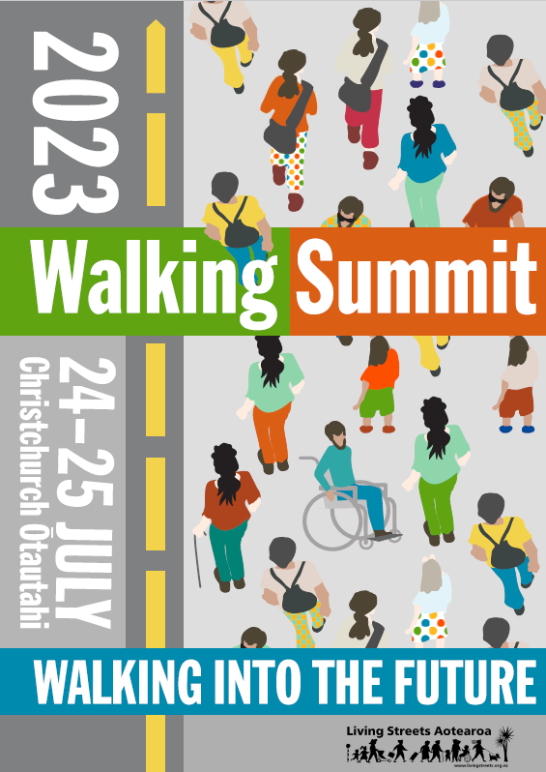

Thank you to our sponsors:
Healthy Families Õtautahi Christchurch
Becky Bliss Design
Walking Summit Programme 2023
Monday 24 July 2023
Time | Speakers |  | Presentation topics
8.30am | Registration  TSB Room, 2nd Floor, Tūranga Central Library, 60 Cathedral Square, Ōtautahi Christchurch
9.30am  Mihi whakatau  Welcome | Maaka Tau, Te Taumata o Ngāi Tūāhuriri  Welcome from Tim Jones, President and Carina Duke, Vice-President, Living Streets Aotearoa
10.00am  Keynote address | John Minto has a life-long involvement in activities that foster equity and social justice. John ran for the Christchurch mayoralty in 2016 campaigning, among other things, for free public transport for all. His political activism is best remembered as the part he played in Halt All Racist Tours (HART). A retired high school teacher, he is currently involved in exposing apartheid in Palestine and is Chair of the Palestine Solidarity 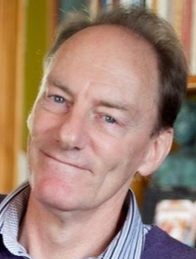Network Aotearoa. |  | Community connections through walking  John is a keen walker who regularly walks from home in Waltham to Lyttelton for a cup of tea before walking back – a 5.5 hour round trip. He walked the Te Araroa trail when he retired a few years back. He will talk about the role of walking in expanding and deepening community connections and will illustrate this with personal anecdotes from his walking experiences.
10.30-11.00am  Morning tea | Check out your walkshop meeting point  Choose your dinner option now!
11.00-11.45am The National Walking Plan  Chair: Sara Templeton | Co-presenters  Alan Meharry, Principal Advisor, Urban Mobility Team, Waka Kotahi  Alan is the project lead for the development of the National Walking Plan and works on a wide range of walking and cycling projects.  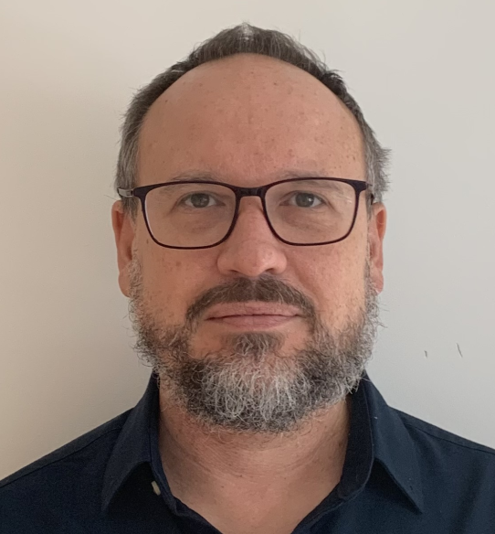  Nick Potter, Principal Advisor, Placemaking and Urban Development Team, Te Manatū Waka Ministry of Transport.  Most of Nick’s work focuses on making it safer, easier, and more enjoyable for people to get around our cities by foot, bike, and public transport. |  | The National Walking Plan  Waka Kotahi is leading the development of a National Walking Plan (NWP), which the Government committed to deliver in the Emissions Reduction Plan. The purpose of the NWP is to ‘significantly increase the safety and attractiveness of walking’. The plan will identify the actions across governance, planning, funding, and delivery of transport and land-use that are needed to foster a culture and environment that values walking. Alan and Nick will provide an update on the plan, and how it relates to other work that central government is doing to support walking.
11.45-12.30am The Climate for Walking  Panel discussion  Chair: Tim Jones | Panel  Danny Eyre, Climate Change Commission. Danny is a Principal Analyst in the Climate Change Commission’s Transport and Urban Systems team.  In this role, he leads analysis and engagement on the transport sector as part of the Commission’s advice on emissions budgets and policies to reduce emissions  Charlotte McKay, Local Government New Zealand.  Charlotte is a Senior Policy and Advocacy Advisor. She has been co-leading LGNZ’s policy work on the Review into the Future for Local Government  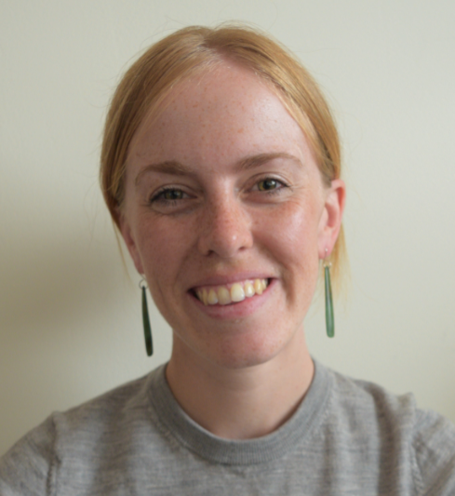  Duncan Webb, MP Christchurch Central since 2017  Prior to entering Parliament, Duncan was a professor, lawyer, and social activist.  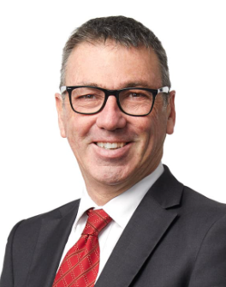 |  | Climate Change Commission: Walking and a thriving, climate-resilient and low emissions Aotearoa Walking can play a foundational role in reducing emission in Aotearoa. This presentation outlines how walking has impacted the Climate Change Commission’s advice-to-date, and how it could in the future.  Local Government's role in placemaking in a changing climate  Councils are on the frontlines of dealing with the effects of a changing climate. The way our cities, towns, rural communities and regions are planned, built and connected has a crucial role to play in creating places that are more resilient to climate change. Let’s talk about the tools and levers councils have at their disposal to work with their communities on climate-friendly placemaking.  A Government Minister and Christchurch MP perspective  Duncan is currently the Minister of Commerce and Consumer Affairs and Minister for State Owned Enterprises.  Christchurch has faced challenges from earthquakes, terrorist attacks and COVID-19. Duncan is committed to making sure Christchurch gets the investment and jobs it needs. Serving in Parliament has allowed Duncan to play a part in making New Zealand a better place through his roles in climate change legislation, resource management reform and COVID-19 response laws.
12.30 - 1.20pm Lunch

1.20-2.45pm Walkshops

1 The Story of Ōtautahi Christchurch (limited to 15) with Kōtane/Waka on Avon. This hikoi will visit sites of cultural significance to Māori both past and present
Meet: 1.20pm. Foundation Café door, Tūranga on Colombo Street (west), where we will walk to the start of the walkshop (Cnr Colombo Streets and Oxford Tce)
2 Walking infrastructure: the good, the bad, the “interesting” with Dr Glen Koorey, former academic and now Principal Transportation Engineer & Transportation Planner at and Director of ViaStrada. This walkshop looks at walking infrastructure: what works and what doesn’t
Meet: 1.20pm. Tūranga side door south (Cathedral Square)

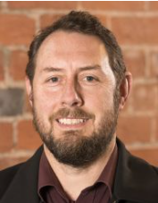

3 Urban play trail with Kate Finnerty, Urban Play Coordinator, Gap filler. Gap Filler have embarked on an ambitious programme to establish Ōtautahi Christchurch as a capital of urban play! Join Kate and explore the streets of the city through the lens of play
Meet: 1.20pm. Tūranga side door north (Gloucester Street)
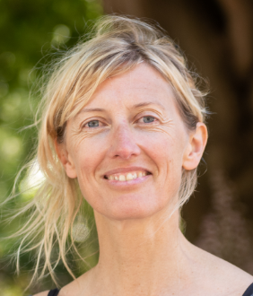

2.45-3.15pm Afternoon tea

3.15-4.00pm Walking and Public Transport  Chair:  Mike Mellor | Holly Smith, Transport Planner, Service Network Development Team, Auckland Transport  Holly is passionate about designing for people and supporting and improving the accessibility of sustainable transport modes. She has five years of experience within transport planning – with a specific focus on public transport and rapid transit. She is currently working on improving access to rapid transit stations through the First & Final Leg.  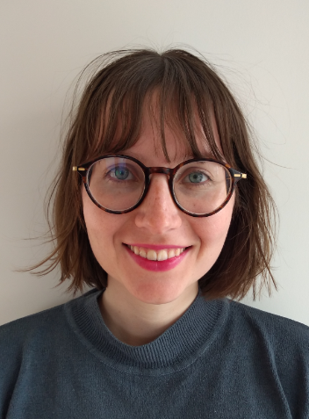  Sarah Thorne, Principal Advisor Public Transport Infrastructure, Christchurch City Council  Sarah is a passionate advocate for inclusive and sustainable public transportation systems. She specializes in enhancing accessibility, safety, and efficiency in transportation networks. Her expertise lies in creating accessible and user-friendly bus stops to improve the overall public transportation experience  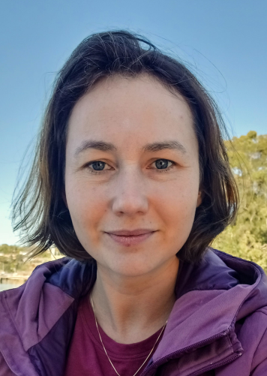  Co-presenters  Gerry Dance, Team Leader Multi-modal, Programme & Standards, Waka Kotahi  Gerry has been working in the Multi-modal area for over 25 years’, with 9 years at a District Council and the last 17 at Waka Kotahi. He currently leads a team of passionate Multi-modal experts who provide technical expertise to the sector and within Waka Kotahi. The team are also the guardians of the Pedestrian Network Guidance, Public Transport Design Guidelines and the Cycling Network Guidance.  Patricia Vasconcelos, Principal Multi-modal Advisor, Programme and Standards, Waka Kotahi.  Patrícia is currently leading the development of the national Pedestrian Network Guidance, involved in the development of the National Walking Plan and the refresh of the Cycling Network  Guidance.  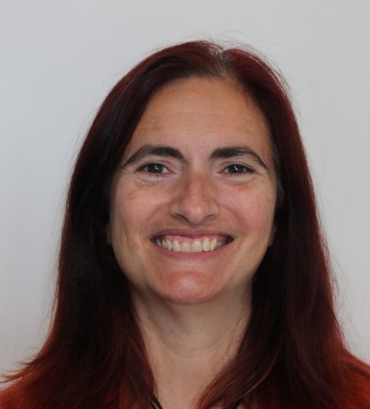 |  | Walking & Public Transport: The First & Final Leg  Bus stop design that works for pedestrians  Public transport journeys consist of much more than the transit itself - the first and last leg is often overlooked but is the one of the most important parts of the journey. This presentation will cover how thinking about access and the pedestrian experience is embedded in public transport planning at Auckland Transport – from how we think about public transport interchanges, plan bus routes, to the way we look at the areas we serve with public transport.  Navigating Boundaries: Creating an Inclusive and Safe Public Transportation Network in Christchurch  This presentation will delve into the often-overlooked world of buses and explore how we can enhance the experience of catching the bus for everyone in Christchurch. So, how can we achieve this goal? We will focus on three key strategies: increasing bus frequency, making buses go faster, and enhancing the overall experience.  Walking and Bus Stops  Waka Kotahi will give an introduction to the Public Transport Design Guidance looking at on getting to and from public transport, the bus stop planning and design sections
4.00-5.00pm Walking to School  Chair: Celia Wade-Brown | Duane Burtt, Principal Policy Advisor, Victoria Walks.  Duane has more than 25 years’ experience as a planner and policy analyst in Australia and New Zealand. In the ten years he has focused on pedestrian oriented town planning and street design. His role includes co-ordinating research, input to policy processes, communications and event management. He has contributed to a range of guidance documents for vision impaired pedestrians, safer road design for older pedestrians, measuring walking and shared walking and cycling paths.  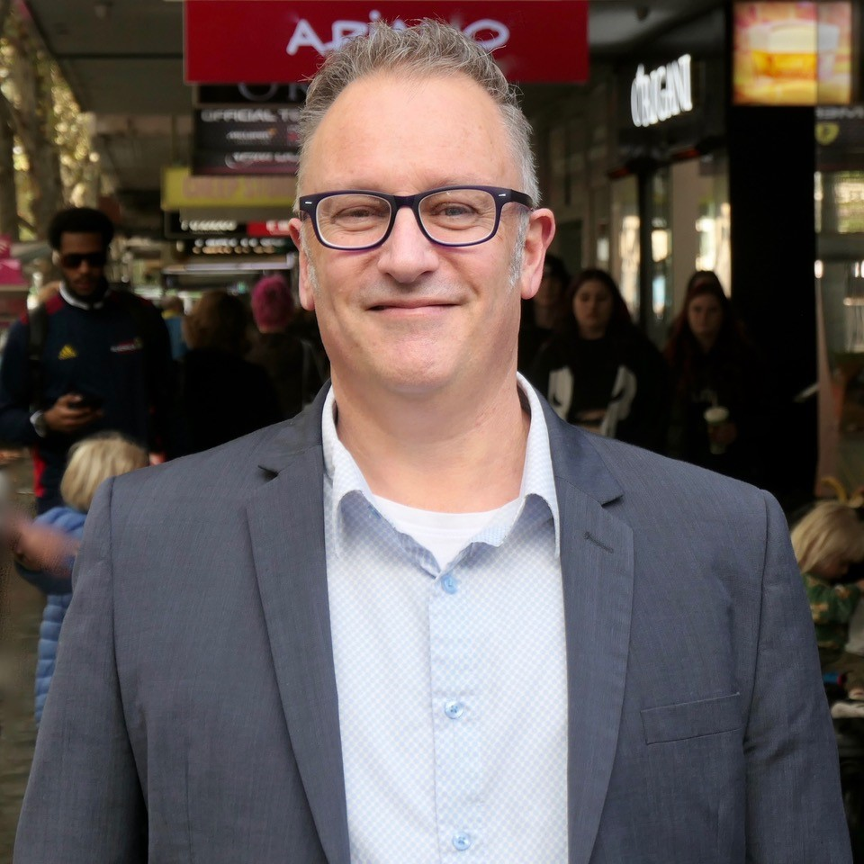  Co-presenters  Ashley Beaton, Community Travel Advisor, Christchurch City Council  After finishing a Master of Urban Resilience and Renewal in Transport at the University of Canterbury, Ashley started working at Christchurch City Council. Her thesis focused on community assessable engagement techniques, monitoring, and evaluation tools for tactical urbanism  George Booty, Community Travel Advisor, Christchurch City Council.  George has worked in behaviour change for over 7 years in Auckland, Wellington and now with Christchurch City Council  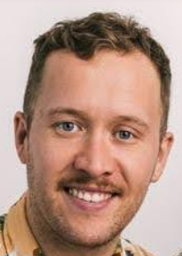  Grace Stapleton, Land Development Team, Abley Consultants. Grace is a Graduate Transportation Planner having completed her Master of Urban Resilience and Renewal and her Bachelor of Science (Geography and Environmental Science) at the University of Canterbury. |  | Lessons from Melbourne  Duane will outline findings from Victoria Walks’ research on how travel to education tends to change at different stages of a young person’s life; and what walking means to young people. He’ll also provide examples of school programs that have successfully encouraged walking.  Walking School Bus and workshop pilot Walking school buses are growing in demand in Christchurch. With more parents and schools wanting to find out about what they are and how to run them Christchurch City Council has developed a Walking School Bus programme. This programme focuses on giving a good overview with opportunities for more support when and where needed.  How Active Transport to School can be encouraged in New Subdivisions  Active transport use in Aotearoa New Zealand is increasingly essential and encouraged as the country strives to become more resilient. Unfortunately, the prioritisation of private transport (e.g., cars) has discouraged active transport in many communities. The real and perceived barriers that prohibit active transport need to be identified and understood to mitigate them. This research investigates how active transport to school can be encouraged in the vicinity of a new subdivision, and how this can enhance community resilience and well-being.
Evening dining options:
While there is no formal conference dinner, the Summit organisers extend a warm invitation for you to attend one of the following restaurants to continue networking and socialising with other delegates:

Mumbaiwala: 120 Hereford Street (300m)
Little High Eatery: 225 St Asaph Street (600m)
Ramen Ria: 3/112 Oxford Tce Riverside market (800m)

All are fully wheelchair accessible and have vegan and gluten free options.
Let us know your choice at the morning break and we will pre-book.

Tuesday 25 July

Time | Speakers |  | Presentation topics
9.00-9.45am  City design for the 21st Century  Chair: Meg Christie | Sara Templeton, Christchurch City Councillor with Climate Change Portfolio. Sara Templeton is a strong advocate for emissions reduction through sustainable transport and urban form, and for building community resilience  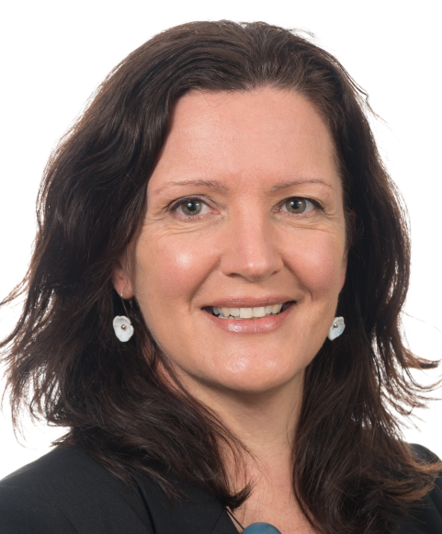  Nicki Williams, Otago Population Health Department. Nicki is a Registered Landscape Architect currently completing a PhD through the University of Otago, researching how to improve urban and transport planning and design outcomes for diverse women. Until recently Nicki was working for the Christchurch City Council and prior to completing a Masters in Landscape Architecture, worked as a Chartered Accountant.  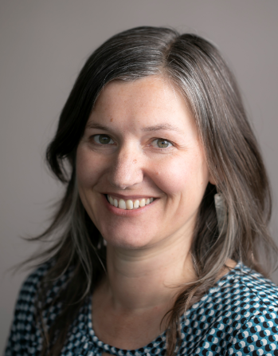 |  | Walking the Talk - Rebuilding a City with People at its Heart  Prior to the devastating earthquakes of 2010 and 2011, Christchurch had acknowledged it had a problem, with a grey and struggling central city and urban sprawl. With the crisis came opportunity and this talk will outline some of the challenges and achievements of the rebuild – and a look to the future.  Walking While Female  The design of our cities and transport systems create different travel experiences for girls and women. Factors such as age, income, ethnicity, disabilities, sense of safety and caregiving roles all impact on the way women travel and the options available to them. This presentation will explore how these factors impact on girl’s and women’s experiences of walking and the opportunities for improving these experiences.
9.45-10.30am The walking future for Ōtautahi / Christchurch  Chair: Carina Duke | Dr Colin Meurk ONZM  Dr Colin Meurk, at Manaaki Whenua, Canterbury and Lincoln Universities, has theoretical and participant interests in biogeography, ecological restoration and design, landscape function, urban ecology and biophilia, subantarctic islands, conservation biology, citizen science (https://inaturalist.nz/), people-nature connectivity, and ‘futures’ solutions (http://cwea.org.nz/lectures.php#topline). Colin is on numerous councils, trusts, advisory and steering groups (ECan Biosecurity), for urban great walks, eco-literacy, teaching and student liaison. He has received a Christchurch Civic Award, Loder Cup, Ecology in Action Award (NZ Ecological Society), Golden Foot Award (2009) http://christchurch360trail.org.nz/), supreme Horticultural Design award (2012 Ellerslie International Flower Show), and most recently an ONZM.  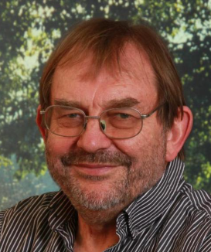  Co-presenters  Jacqui Miller, Community Recreation Advisor, Christchurch City Council  Since joining Council Jacqui has worked predominantly in the East of Ōtautahi engaging with communities to develop accessible, inclusive and diverse recreation opportunities. The aspect of her role she enjoys the most is establishing and building relationships. Jacqui loves to walk, it’s the best ‘reset’ button ever  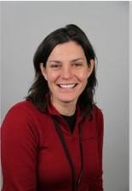  Helen Miles, Community Recreation Advisor, Christchurch City Council.  Helen’s career has been dedicated to empowering communities and individuals to access and develop recreational opportunities of their choice. Helen is a keen walker and has enjoyed many great walks around Ōtautahi, and the South Island  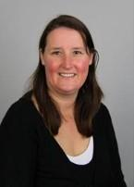  Co-presenters  Sarah McKay, Community worker, “Common Ground”, Sustain South Brighton  Sarah has a background in community-based research and evaluation. Over the past 20 years, she has worked with various Youth Development and Community Development organizations. She has a post-graduate diploma in Social Service Sector Research Evaluation from Massey University, with a focus on evaluation in Youth Development and Community Development settings. She has developed Common Ground - a popular community connecting space with a greenspace, community garden, book fridge, toy boxes, a Tiny Shop, outdoor seating area, a permanent coffee cart and place for community events and activities..  Maria Smolar, Lead System Innovator, Healthy Families  Maria is a public health professional with over 16 years of experience in Christchurch and internationally. Currently her role focuses on identifying opportunities for scale and impact through system-level experiments, design challenges, and prototypes. Maria is particularly interested in speculative and future design, constantly exploring innovative solutions and possibilities for the future of public health.  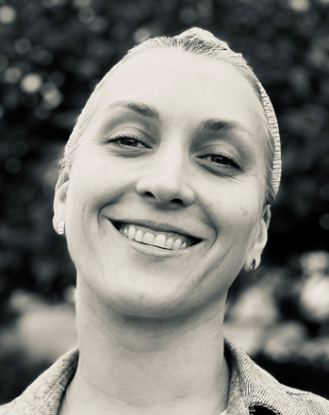 |  | First Urban Great Walk of Aotearoa – a Model for Your City  As we come to terms with deeper measures of ‘wealth’ and well-being around gentle engagement with nature, the notions of pilgrimage, Shinrin Yoku, Hikoi, and slow meditative walking come to the fore. I’ll take you on a (quick) slow walk around the Christchurch360Trail – it shouldn’t take more than 12 days – and show how it legibly reveals all the layers of history – feeding identity, awareness, and eco-cultural literacy. Every school child and City Governor should experience these perspectives to understand their place and what it is they are managing – in line with stewardship/kaitiakitanga. Looking back at the way you have come and completing the circle is the way forward - for all cities to provide for their citizens and visitors, showcasing each place uniquely, pushing back the technocratic belief that people and nature belong in separate realms.  Lessons from the Walking Festival  Born from the earthquakes in 2011, initially The Walking Festival focused on connecting people and places to support communities in their recovery. A review in 2019 affirmed and reset the direction of the Walking Festival to Hōpara, Ako me Hono, explore, learn and connect.  The two week festival hosts over 55 walks across Ōtautahi, Selwyn and Waimakariri. Whether walkers are a fan of local history, getting out into nature, or huffing and puffing to get that awesome view, there’s something for all ages and abilities.  Helen Miles and Jacqui Miller will share the insights and lessons learnt during the Festival’s 10 years emphasising the importance of strong partnerships and ways to reach those who haven’t yet discovered the joy of walking.  From safer streets to healthy streets: A pilot project of the Healthy Street’s framework in South Brighton. This presentation introduces the ongoing journey towards transforming South Brighton's streets from mere safe passages to vibrant and healthy spaces that encourage walking, cycling, and community engagement. The local community, in collaboration with Sustain South Brighton, The Bridge Hub, Healthy Families, and Te Mana Ora, are actively involved in the co-design process to enhance street design for improved safety and enjoyment.
10.30-11.00am Morning tea | Sign up for the short lunchtime walk
11.00-12.15pm What do Inclusive streets look like?  Chair: Glen Koorey | Professor Shanthi Ameratunga, School of Population Health, University of Auckland. Shanthi is an Honorary Professor and a Consultant/Senior Medical Researcher at Middlemore and Kidz First Hospitals at Te Whatu Ora Counties Manukau in South Auckland. A paediatrician and public health physician by training, she leads a multi-disciplinary research program focusing on injury prevention and trauma outcomes, disability and accessible transport.  Professor Simon Kingham, School of Earth and Environment, University of Canterbury  Simon is an Ahorangi/Professor at Te Whare Wānanga o Waitaha/University of Canterbury where he teaches and undertakes research on the impact of the urban environment on wellbeing, with a specific focus on transport. He is also seconded to Te Manatū Waka the Ministry of Transport as their Kaitohutohu Matua Pūtaiao/Chief Science Advisor where his role there is to ensure that policy is evidence-based.  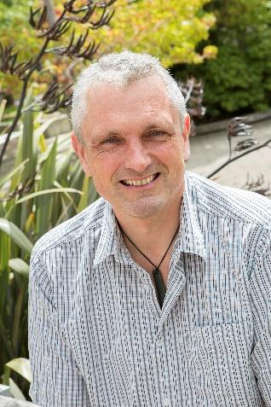  David (Rolly) Rowland, Southern Area Programme Manager for Road to Zero, Waka Kotahi.  Rolly works with 20 local councils across the South Island to develop and deliver their Road to Zero programmes focusing on reducing deaths and serious injuries on their local networks.  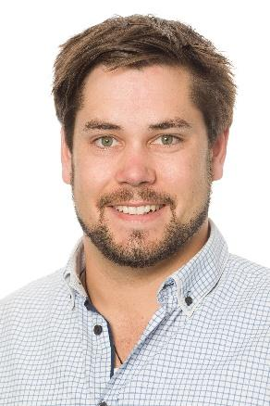  Jeanette Ward, Technical Director, Abley.  Jeanette works across transport planning, engineering and safety providing technical leadership. She is a Chartered Professional Engineer with 30 years of diverse engineering experience. Jeanette understands the people-based approach to planning and design and brings this all together in her projects. She was involved in developing Pedestrian Network Guidance for Waka Kotahi.  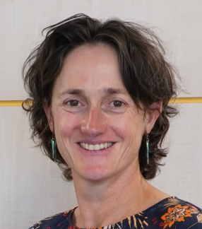  Co-presenters  Emily Ward, University of Canterbury / Te Manatū Waka (Ministry of Transport)  Emily recently completed their Master of Urban Regeneration and Renewal at the University of Canterbury. She is a policy advisor working on public transport policies  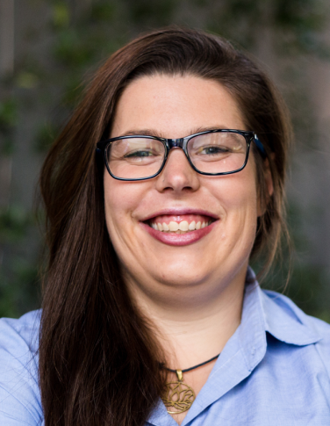  Nick Reid,.University of Canterbury/ Via Strada  Nick is a transport engineer in Ōtautahi, after graduating in 2021. He is passionate about creating healthy, vibrant and equitable neighbourhoods/cities through active transport planning and design here in Aotearoa.  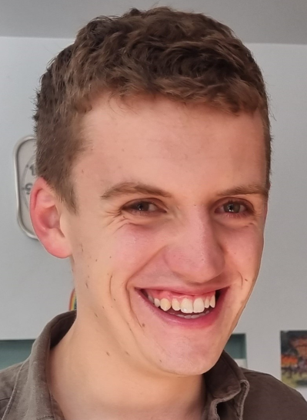 | Shanthi is presenting on behalf of the Inclusive Streetscapes Project team about lessons learned from a community-based participatory research project in Tāmaki Makaurau. The project engaged with residents in four ethnically and socio-economically diverse case study sites to explore how kaumaatua/older residents and disabled people construct the meaning, value, and challenges of walking and getting about more generally. The project explored relationships between historical and present-day transport planning and infrastructure and community perspectives on safety and access to mobility, health, and wellbeing. Neighbourhoods with inclusive transport options and street connectivity welcomed opportunities for walking, social engagement, and joy which, to some extent, could mitigate some of the challenges of poverty, physical impairments, and social isolation.  The potential for walkable street spaces to enhance wellbeing Streets are usually seen as places for motor vehicles, but what happens if we think differently and start prioritising people. This presentation will look at what can happen when we make streets great places to walk focusing on two studies carried out in Ōtautahi Christchurch.  Raising the Golden Foot Award for Wairarapa – Raised Pedestrian Crossings on State Highway 2 Living Streets Aotearoa awarded Waka Kotahi and Wairarapa Road Safety Council the Urban Connection Golden Foot Award in 2022 for the Wairarapa State Highway 2 Safety Improvements project. As part of these safety improvements, we have improved and raised several pedestrian crossing points on SH2 in the Wairarapa. This presentation will cover why we’re raising pedestrian crossings, what we’ve done to date in the Wairarapa and the impact that these raised crossings have had on our communities along SH2.  Planning and designing with a gender lens  Planning and design guidance recognises that many different types of people are using the pedestrian network/places. In recent years the guidance for catering for people with varying disabilities has vastly improved but there is still work to do on differences such as gender. Crime Prevention through Environmental Design (CPTED) guidance can help with ensuring places are designed with personal security in mind but there are many other aspects to embed in our practices. This presentation will examine a Gender Equality Toolkit developed in the UK that could be a useful starting point for NZ.  Age-friendly design: Bursting with Stride! Understanding the perceptions of walkability in Central North Christchurch for older adults.  By developing walkable streets, Christchurch can create neighbourhoods that are attractive to new residents and care for existing ones. The research wanted to find out what is the perceived walkability for residents over 55 years and what walkability factors attract or deter older people to Northern Central Christchurch.
12.15-1.00pm Lunch and optional 30-minute walk (2.3km). | Lunchtime walk  Meet: Side door, Tūranga on Gloucester Street at 12.20pm. Come on an optional brisk walk taking in historical New Regent Street, Ōtautahi Orchard, historical Victoria Square, then onto the City Promenade (built post-earthquake) to Riverside Market (inner city farmers market).  Back via the shortest route in time to fill a plate to nibble off for the 1pm session.
1.00-2.00pm How do we achieve pedestrian improvements?  Chair: Craig Stansfield | Co=presenters  Patricia Vasconcelos, Principal Multi-modal Advisor, Programme and Standards, Waka Kotahi  Patrícia is currently leading the development of the national Pedestrian Network Guidance, involved in the development of the National Walking Plan and the refresh of the Cycling Network Guidance  Ann-Marie Head, Chartered Professional Engineer, Abley  Ann-Marie has a focus on planning and designing for better multi-modal and active transport in urban environments that encourage and support people to be safe, healthy and happy whilst minimising environmental impacts. She works with Waka Kotahi and Austroads to develop guidance and set best practice standards.  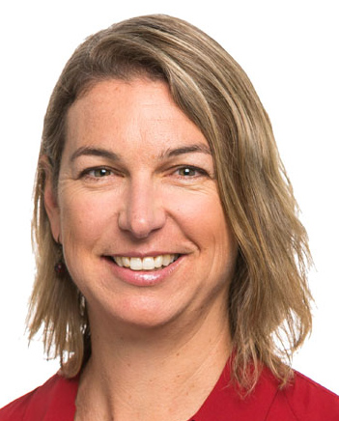  John Lieswyn, Director and Principal Transportation Planner, Via Strada. John is a fellow of the Chartered Institute of Highways and Transportation and an Institute of Transportation Engineers certified Professional Transportation Planner. He co-authored Waka Kotahi’s Pedestrian Network Guidance. He is often seen walking or biking around Christchurch with his Doberman.  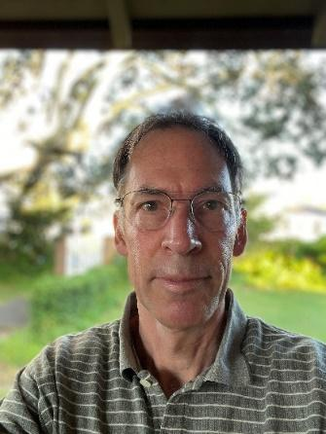  Sarah Free, Wellington City Councillor  Sarah Free has been an elected councillor for Motukairangi/Eastern Ward of Wellington City since 2013 and served as Deputy Mayor from 2019 to 2021. She has a keen interest in transport issues and held the walking, cycling and public transport infrastructure portfolio at WCC for six years.  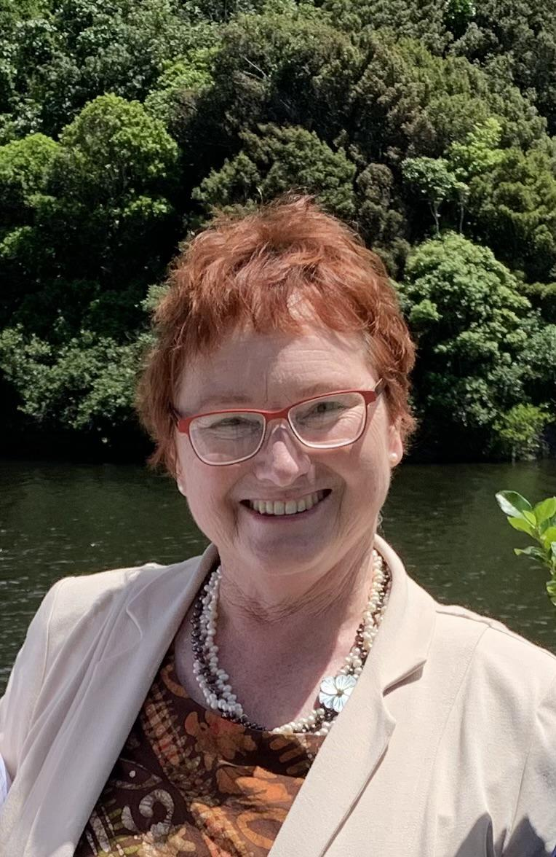 |  | An overview of the Waka Kotahi Pedestrian Network Guidance (PNG)  The PNG sets out ways to improve New Zealand’s walking environment. It provides a ‘one-stop-shop’ of best-practice guidance specifically suited to New Zealand’s regulatory and operating environment. The presentation will focus on why there is need for pedestrian guidance, its development process, what it covers and what the next steps will be.  We can quantify the economic impact of investing in roads for motor vehicle drivers, why not pedestrians? Ultimately it would be preferable to invest in walking on the basis of strategic objectives (“it’s obviously the right thing to do”) however funding for area-wide walking improvements still requires an economic assessment. We already have a dollar value for each new pedestrian attracted to an improved environment, but how many pedestrians can we expect? Transport demand models with a pedestrian component are expensive and generally not used in our smaller cities and towns. This presentation describes a simple model to estimate the uptick in walking based on comparing the walkability of the subject urban area and a benchmark (better) urban area. Initial findings show promise but also limitations to the approach. All of us have a role to play in the solution.  Pedestrian improvement - a real life example from Wellington  A narrow, shared footpath adjacent to a 70km/hr highway was transformed into a fully accessible, separated cycleway and walkway, with access to a restored natural environment and beaches. Toilet facilities, seating and a newly completed pedestrian crossing have enhanced convenience and connectivity. The increase in the numbers of people walking, running or using active transport along the route has been remarkable.  -
2.00 - 3.00pm  Walking into the Future - Pedestrian perspectives (panel)  Chair: Ellen Blake | Five people who walk for transport and enjoyment will speak on their everyday lived pedestrian experiences, people with experience of disability, as parents, and as advocates  Carina Duke  Carl Lintott  Ed Hill  Ingrid Robertson  Judi Whittingham
3.00 - 4.00pm  Closing session - a call to action | Tim Jones, President of Living Streets Aotearoa. Tim is a writer and editor by profession. He has been a keen pedestrian since childhood and has been involved in campaigning for a low-emissions future for many years. He is a former Convenor of the Sustainable Energy Forum and former Co-Convenor of the Save the Basin Campaign.  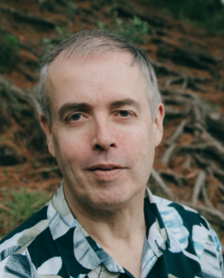  Carina Duke, Christchurch coordinator, Living Streets Aotearoa |  | What do we need for a walkable future?  A Call to Action to ensure that all the plans currently being made to improve walking produce meaningful actions that make it safer and more pleasant to be a pedestrian, and that place walking as a central component of a climate-friendly transport system.

