Submission on John Wilson Ocean Drive Management Plan

Objections to or suggestions on the draft section:
Living Streets Dunedin supports the draft management plan, with the proviso that any mention of motor vehicles (and separate pedestrian access ways) refers to the lower section of the Drive only, with the upper section remaining vehicle free apart from designated service vehicles. It is slightly disconcerting to see no mention of the partial closure over the last few years and the impact this has on the current situation. For example, saying that it is well used by tourist coaches seems out of date considering the statements about the poor state of the road.

(As a matter of interest, the lookout at Unity Park off Eglinton Road is closer to the city for vehicles than St Kilda, and is very well used by tour buses for its stunning views. John Wilson Ocean Drive has special accessibility appeal for tourists and locals who are walkers (and cyclists) because of its accessibility by public transport and its flat approach.)

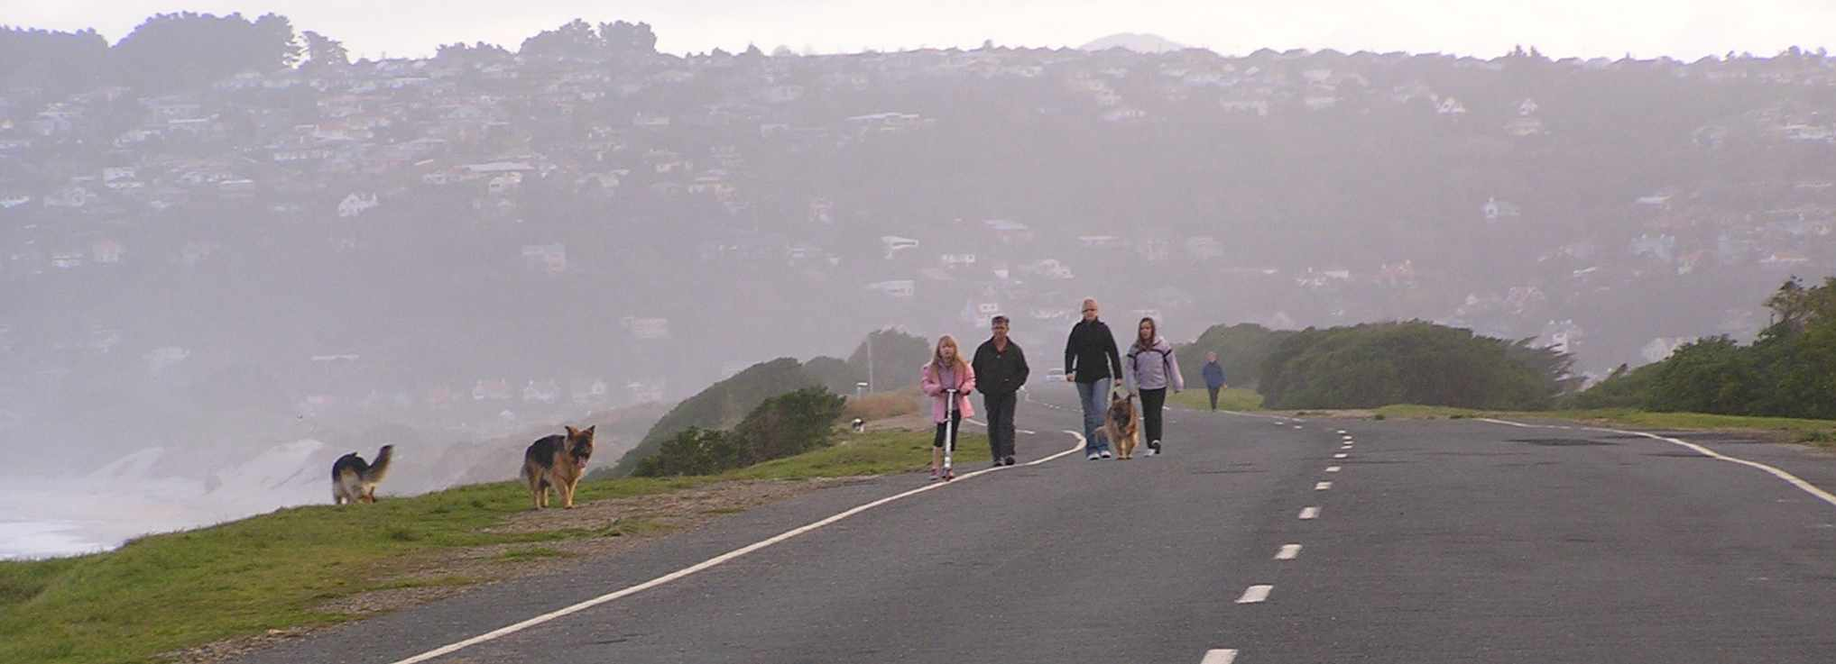

Reasons
As we see it, the beauties of this one kilometer of coastal road, so close to the city yet separated from its bustle, should be preserved for active recreation, wildlife appreciation and peaceful contemplation. This would be made extremely difficult by the admittance of motor vehicles beyond the current closure point, especially given its attraction for gatherings of what have been stereotyped as “boy racers”. Experiences related to us show that such activities can occur on the Drive at any time of the day and week, and are not just confined to late nights. The wide tarmac of the Drive makes a safe and sociable surface for pedestrians of all ages and capabilities, including those needing wheelchairs and mobility scooters, who are also our constituency. Motorists who do not want to leave their cars are also catered for at present as they can drive and park half way along the Drive for an outstanding view of the whole bay.

The arguments in favour of walking among other forms of active transport and recreation are well-rehearsed, so we would like to promote one very important, but under-publicized one – the economic benefits. Living Streets Aotearoa has just hosted a national walking conference entitled the “Dollars and Sense of Walking”, which was full of examples where minor and relatively inexpensive infrastructure changes created a large cost benefit ratio for the surrounding community. One such was the New Plymouth coastal walkway, which the Minister of Transport, Stephen Joyce praised in conference as doing more for the self-confidence of that city than any other measure. The economic benefits of converting John Wilson Ocean Drive to John Wilson Ocean Promenade are many. In no particular order:

1. Dunedin-wide economic advantages
No citizen would leave Dunedin, nor any tourist refuse to come, if the Drive officially became a walkway, but the converse is likely to happen. If an all-weather car-free coastal walk was marketed in the developing portfolio of city-wide walks and cycle-ways, it would be an extra drawcard for those who are attracted by Dunedin’s reputation as a heritage and wild-life centre of excellence. John Wilson Ocean Drive would have extra clout for tourists because of its accessibility by public transport, its setting within an existing green space and the possible plans of Forest and Bird to attract nesting birds back to a car-free Lawyers Head. The possibility of combining the Drive in a near continuous ocean walkway similar to the one that has been so successful in New Plymouth is another positive (The eroding beach is no longer a reliable link in such a walkway, and the scramble down and up does not suit all levels of ability)

2. Local economic advantages for St Kilda
South Dunedin is often portrayed as a struggling area, in search of new initiatives to revive it. The promotion of a local recreational and nature precinct could provide more local opportunities for small businesses such as cycle hire, walking and nature tours and refreshments. It could complement the more “urban chic” atmosphere of the St Clair Esplanade, and the simple summer appeal of the beach, increasing the number of visitors to South Dunedin rather than spreading them more thinly. Research presented at the Walking Conference showed the “halo effect” of improved neighbourhood property prices following improvement in walkability and quality of life in an area (Martin Wedderburn, Paving the Streets with Gold) .

3. National economic advantages
These are the more widely publicized advantages of walking promotion – personal health improvements reducing national expenditure, greater willingness to use active transport modes with reduced reliance on imported fossil fuel, etc. At the moment, because of its uncertain future, the Drive is un-promoted, both locally and city-wide, as a recreation resource, but has still been discovered by many. There is the potential to market it much more widely, in particular to kindergartens and local rest homes as a safe, easy environment in which members can learn and relearn the skills that are so important for continued mobility, and also the life-enhancing benefits of direct contact with nature. (See http://wildthecity.wordpress.com/background/ ) This can be done without compromising its “wild” appeal for more adventurous citizens, as there is plenty of room for all. The current length of just over a kilometer is enough to allow some useful exercise.

4. Council economies
Given the difficulties stated in the draft plan with the Drive formation it seems obvious that keeping vehicles from using the eastern end of the Drive will require much less expensive road maintenance than re-opening the road to cars. Similarly, traffic calming measures along half of the Drive instead of its whole length could be a saving. There has also reportedly been a measurable decrease in vandalism and other incidents since the road was closed halfway, which has probably reduced security and maintenance expenses, both for Council and police. Much evidence was presented at the recent Walking Conference about the huge cost/benefit ratios that could be achieved by less expensive pedestrian friendly initiatives, compared to more costly roading exercises.

Changes or decision we would like the Council to make:
Living Streets Dunedin supports the retention of the last kilometer of John Wilson Drive as a vehicle free precinct, with the barrier and parking left at more or less the current position, though with considerable amenity enhancement. Furthermore, we would like to see a designated footpath marked out between Kettle Park and this portal, wide and protected enough for prams and mobility scooters.

We would like to see the lower section of the Drive traffic-calmed by whatever methods the traffic engineers think of as most appropriate (eg, road narrowing, passing bays, plantings, blocking of line of sight down the road, etc) to ensure that motor vehicles CANNOT travel at more than 10kph, and that only light vehicles can enter the Drive.

If, against our submission, a decision is made to allow cars along the whole length of the drive (and mobility access for those unable to walk is the only reason we could see to justify such a position) the same need for severe traffic calming would necessarily apply along its whole length, and would need to be carried out while the walkabiity of the top section was preserved throughout the process.

In other words, we do not want John Wilson Ocean Drive to return to the open highway it has been, and still is for half its length, because this situation deprives increasing numbers walkers of 90% of the pleasure they gain from the current environment and makes them much less likely to use it.

Living Streets Dunedin.
Living Streets Dunedin is a pedestrian advocacy organisation, a branch of Living Streets Aotearoa. We have over 500 contacts on our local email list, all of whom were invited to contribute thoughts for this document. http://www.livingstreets.org.nz/regions/dunedin

This submission represents the official postion of our organisation. We recognize that individual members may have a range of varying positions and we have encouraged our contacts to make their own submissions.

We do wish to speak to our submission.

