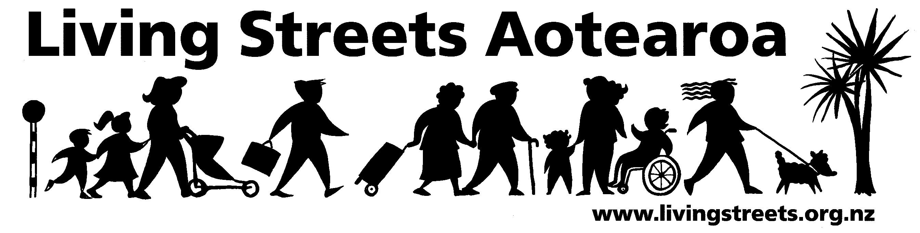

Living Streets Dunedin submission
on Dunedin City Council Draft Annual Plan 2010-2011

Name of Submitting Organisation | Submitted by Judy Martin  (Living Streets Dunedin Co-ordinator)  on behalf of Living Streets Dunedin
Postal Address | C/O of Judy Martin  42 Greenlaw St  Waikouaiti 9510
Phone | (03) 465 8437
Email | jmartins@ihug.co.nz

12 April 2010
Introducing Living Streets Dunedin
Living Streets Dunedin is a pedestrian advocacy group established in 2007 as a branch of Living Streets Aotearoa. Its objective is to support Dunedin walkers and make our city a great walking environment for all. Living Streets Aotearoa’s vision is “More people walking more often”.

For more information about Living Streets Aotearoa see www.livingstreets.org.nz

We wish to speak to our submission.

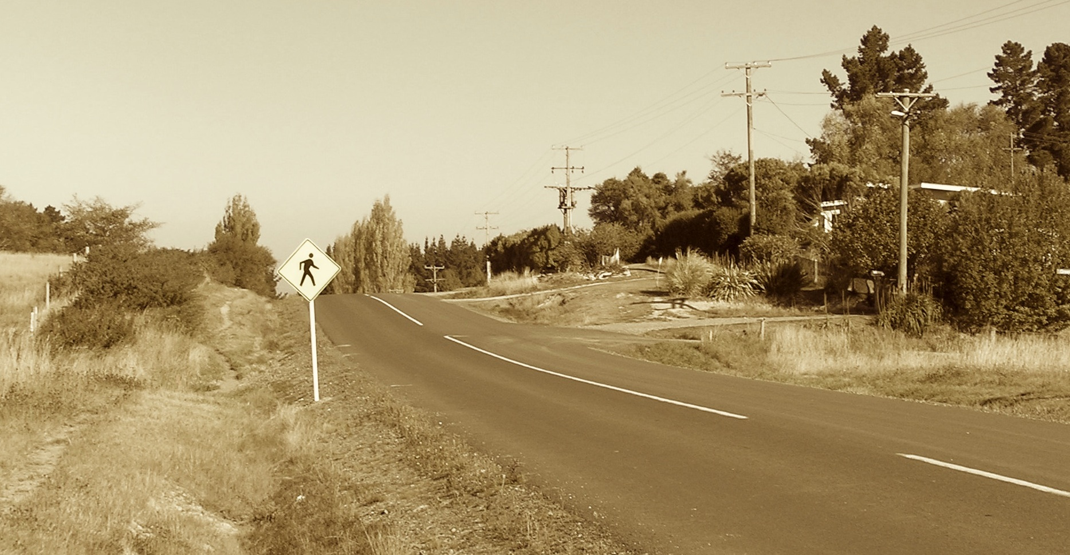
Living Streets Dunedin would like to congratulate the City Council for a continuing awareness of and focus on pedestrian issues. This is demonstrated in the separate budget lines in the annual plan (p.29) for the “pedestrian facilities programme” and of course the “mobility facilities programme” as by no means are all of our footpath users able to walk along them with ease. The commitment is shown visually by the increasing number of “pedestrian” signs that are mushrooming all over the city, including the one shown on the front page which popped up on a Waikouaiti road only last week. However table 1.10 on page 23 with its steep increase in pedestrian fatalities in Dunedin shows how much work is still to be undertaken. We also want to emphasize that improvements for pedestrians are not just about safety – if walking our city streets is a pleasant experience, the number of walkers will increase, with personal health and well-being benefits, and the volume of cars on the roads will similarly decrease, with matching benefits in improved travel times and cleaner air, among other positives. The table on p. 129 acknowledges that improving walking facilities has economic, environmental and social benefits.

Living Streets Dunedin would like to submit the following recommendations.

- Follow the recommendations in the Ministry of Transports Safer Journeys national safety strategy regarding speed reductions on relevant urban and rural roads and around schools.

“Create more speed zones on high risk rural roads to help make roads more self-
explaining, and to establish the criteria for what roads with different speed limits should
look like (eg 80 km/h, 90 km/h, 100 km/h)” SJ p.3

“Increase the adoption of lower speed limits in urban areas” SJ p.3

“Increase coverage of temporary lower speed limits around schools” SJ p4

These summary recommendations from the Safer Journeys document are discussed and justified in detail later in the same document, especially the dramatic reduction in pedestrian fatalities when car speeds drop below 50kph. It is our understanding that the Council has discretion to set speed limits within its boundaries, so it would be good if you could apply this discretion to lower speeds around schools, suburban streets where pedestrian traffic is high or needs to be encouraged, and especially urban and rural streets where there is inadequate footpath provision and too much traffic to allow people to walk comfortably or safely. An urban example of the latter is Lancefield St in South Mornington, a rural example is the Warrington-Karitane road around Seacliff, which is manifestly unsuitable for a 100kph zone. Now a national standard is emerging, it would be good if DCC transport planners could help influence that policy, as well as follow it.

- Prioritize the “pedestrian facilities programme” footpath development budget to provide safe and comfortable pedestrian access along routes that are the only practicable way of travelling between two adjacent areas on foot.

We commented in our submission on last year’s LTCCP on two such necessary links, between Waitati and Evansdale, and between Green Island and Waldronville. Since then, the former has been much improved, probably with Ministry of Transport funding as it is part of SH1. We hope that the DCC will now encourage MoT to extend their interest to another problem linking route on SH1, the few kilometres of road between Waikouaiti and the Karitane turnoff, which have some sections without adequate protection from traffic which make it very problematic for walking or cycling between those neighbouring communities. We have been informed by a member that no action has been taken on improving foot access between Green Island and Waldronville and hope this can be remedied as soon as possible.

- Show a visible commitment to walking as a healthy and community-enhancing activity by supporting symbolically important walking routes which help brand the city as “pedestrian friendly”

The commitment to extending the cycle and walkways on both sides of the Harbour are very welcome in this respect, but there are others, as well.

John Wilson Ocean Drive

Since this road was closed to traffic for the building of the sewage outfall its advantages as a sealed scenic surface for walking, family activities, novice cycling and safe road access for the elderly and those where impaired mobility have become apparent. Partly because of this, and partly because of public health and conservation concerns the council has delayed re-opening the drive to traffic. However, there are obviously quite a large proportion of the population who aren’t able to take advantage of the active transport opportunities and want to be able to drive down it again. The Council has a hard task meeting all these demands, but Living Streets Dunedin asks that any solution preserves the ability of pedestrians, especially families and those with impaired mobility to enjoy the promenade without the threat and inconvenience of motor traffic. Whether that is achieved through infrastructure changes, major traffic calming or some sort of timetabled sharing, we leave to the wisdom of traffic engineers and planners to work out a solution that satisfies all users.

Leith Valley Road

We repeat our request, in our submission last year, that Leith Valley Road remain unsealed, so that it remains a low car use road and thus can maintain its position as a favourite destination for local walkers, runners and cyclists.

Caversham tunnel project

It is great that the project of re-opening the old Caversham rail tunnel as a cycleway and footpath through the Caversham hills is being actively considered, and Living Streets Dunedin would like to express its support. Pulling together a path through the Southern cemetery, along the southern reaches of the town belt, through the tunnel and on through Green Island would create a potentially iconic walking route through some of the most historic, scenic and interesting parts of the city, in addition to the cycle and walking routes being developed as part of the Caversham road upgrade.
- Consider the impact of any infrastructure and economic changes decided on by council on citizens who prefer to walk, citizens who have to walk, and citizens who are in situations that make using roads and footpaths difficult or hazardous.

There are many more projects and developments that have the potential to impact on walkers and footpath users than can be mentioned in this submission. We would like the above perspective to always be held in mind during the decision making process, especially as the costs of motor transport increase and the personal and public goods associated with increased walking become more widely accepted.

The signs are a good start, but just a start.

Thank you for your consideration

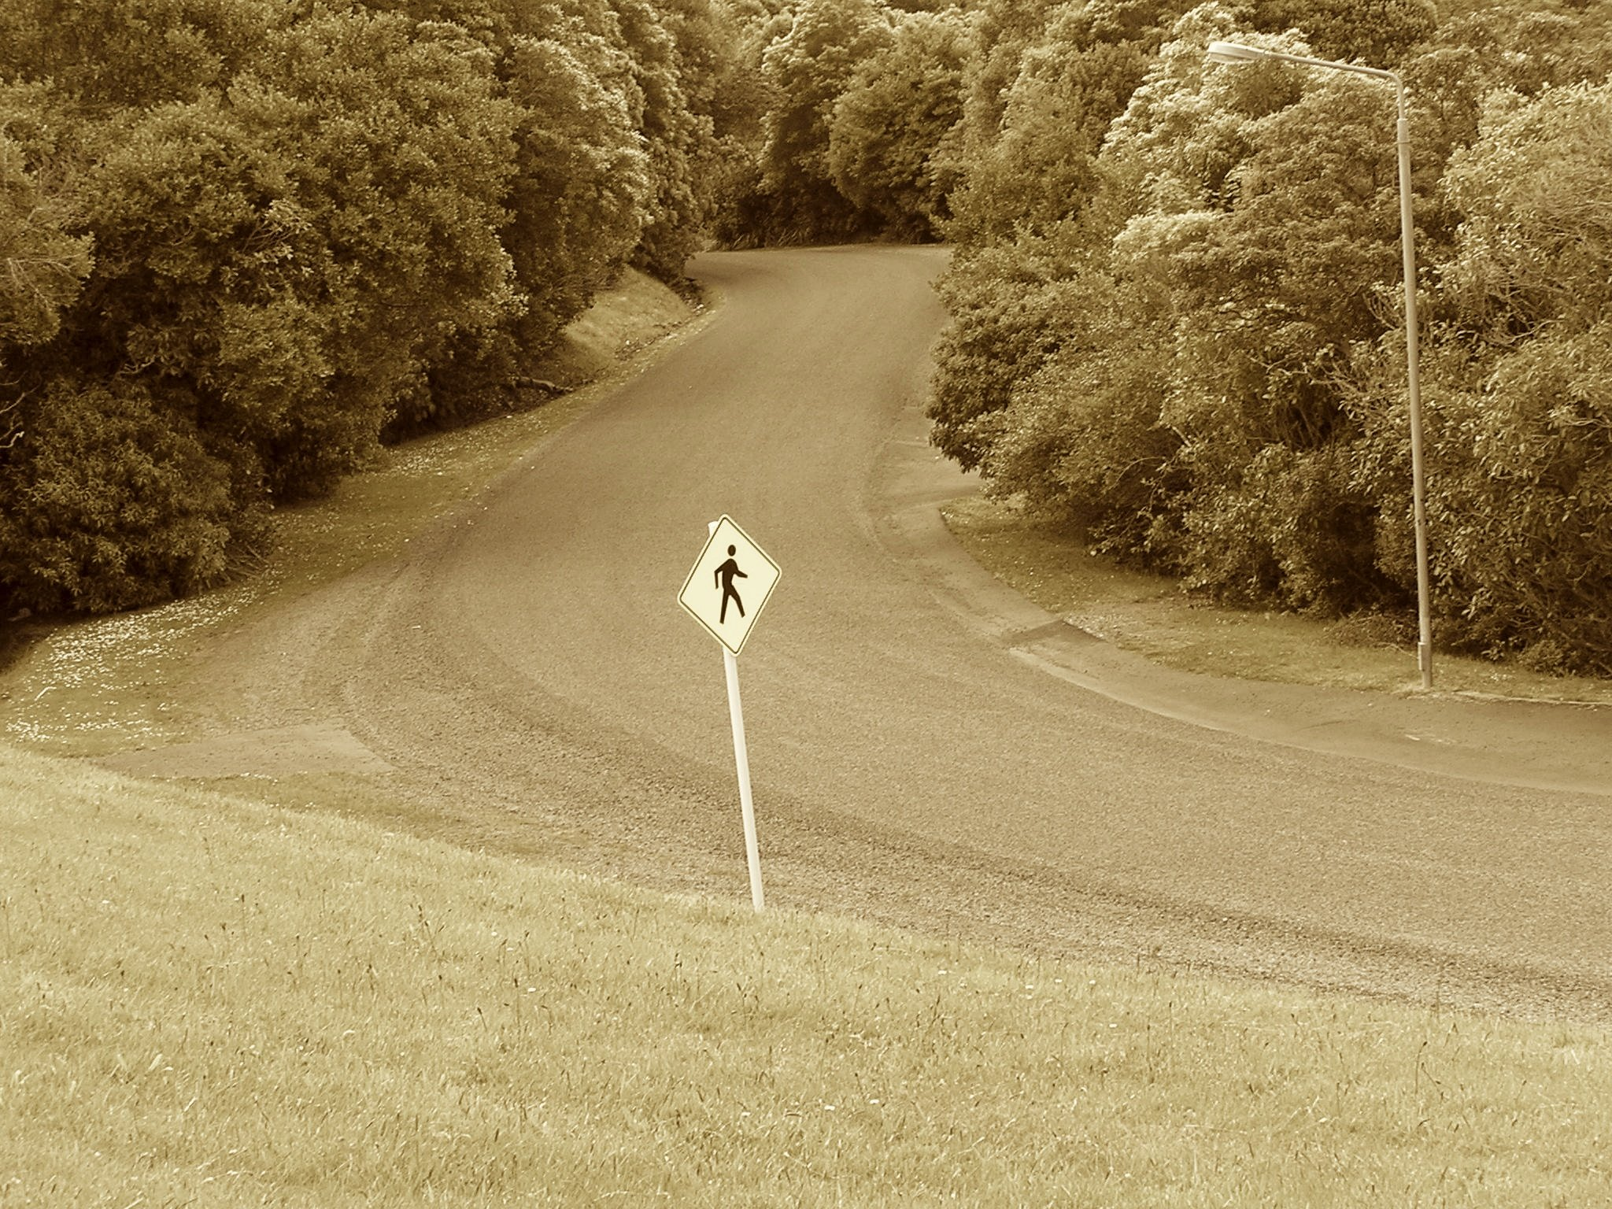

Living Streets Dunedin

