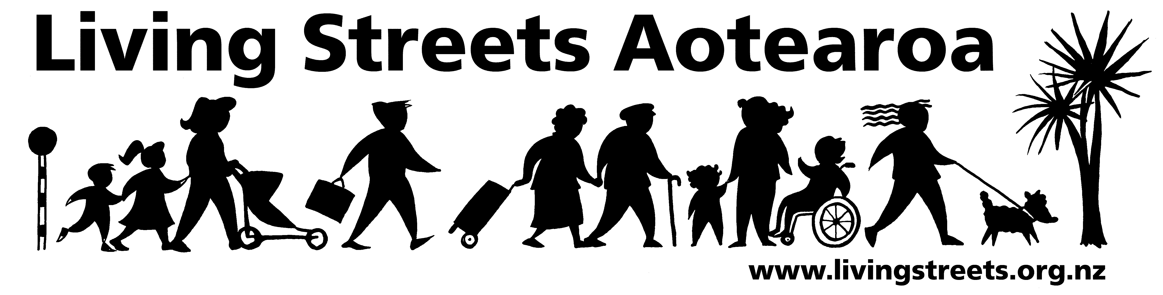

FACTSHEET

- Vision:

More people choosing to walk more often.

- Background:
Living Streets Aotearoa is New Zealand’s national walking and pedestrian organisation, established in 1998, and incorporated in 2002. Living Streets works to develop walking-friendly communities throughout New Zealand and to promote the social, environmental, health and economic benefits of walking as a means of transport and recreation.

Living Streets exists because the diverse needs and aspirations of people on foot are often overlooked. Walking is not consistently or fully integrated into decision-making in transport, urban design, public health and community development planning.

Living Streets has taken up the challenge to address these issues, by working with communities, and public and private sector agencies at all levels to provide education, practical advice and expertise. Through these activities Living Streets aims to help shape policy and infrastructure to support pedestrians and walkers, and to encourage more people to get out and about on foot more often. We emphasise the relationship between walking and access to public transport.

Walking is a significant part of Climate Change and Public Health solutions.

- Organisation:
Living Streets Aotearoa is led by an Executive Council including the President, Peter Kortegast, and is supported by a membership of transport, road safety, urban design, health and recreation professionals as well as passionate citizens from around New Zealand. Living Streets has an office in Wellington, with two full-time and one part-time staff member, and offices in Christchurch and Auckland with one part-time staff member in each.

- Objectives:
- To promote walking as a healthy, accessible, cheap, sociable and environmentally-friendly means of transport and recreation.
- To promote the social and economic benefits of pedestrian-friendly communities.
- To work for walking-friendly communities with improved access and conditions for walkers, pedestrians and runners.
- To advocate for greater representation of walker and pedestrian concerns in land use and transport planning and urban design.
- To raise the profile of walking through education, debate, campaigns, publications, seminars and conferences.
- To foster consideration for people with special mobility needs
- Key Activities

- promoting walkable, healthy, safe communities
- developing a nation-wide network of community-based Walking Action Groups and regional Walking Stakeholder Forums
- influencing the development and shape of key policy documents by making submissions to central and local government, which identify the needs of pedestrians, and explain how meeting their needs increases the liveability of our towns and cities.
- networking with similar walking and pedestrian advocacy groups internationally.
- collaborating and networking with strategic partners in central and local government, business, and the public and private sectors
- providing information and advice for the general public and for key stakeholder groups on a range of walking issues
- maintaining our website www.livingstreets.org.nz and its associated email discussion group, and producing a quarterly newsletter “Footprints”
- organising the biennial New Zealand Walking conference
- organising the biennial Golden Foot Awards
- initiating research into walking related topics
- contributing to the “Getting There – on foot, by cycle” strategy and its implementation
- maintaining the walking resources database, WalkIT
- fundraising for core and project work

- Projects:
In addition to its core work, Living Streets is involved with a number of projects including:

- Running Community Street Reviews to assess the walkability of routes
- Developing Walking Maps and signage to help residents, workers and visitors to find their way around communities on foot
- Publicising and promoting The International Walking Charter.

- Funding
Living Streets Aotearoa’s national funding comes from contracts with the New Zealand Transport Agency and from other agencies, from grants and from private sponsorship.

- Walking Action groups
Living Streets Aotearoa supports Walking Action Groups in Auckland City, North Shore, Manukau, Waitakere, Hamilton, Taupo, Palmerston North, Wellington, Lower Hutt, Nelson/Tasman, Marlborough, West Coast, Christchurch, and Dunedin. We are working with local people to establish more groups. These groups work with their local councils, sports and health groups and other agencies to promote walkable communities. Contact details are on our website. www.livingstreets.org.nz

- Strategic partners
Living Streets Aotearoa recognises the wide range of organisations working to promote, encourage and support the needs and aspirations of pedestrians. We believe that co-ordination between local, regional and central government agencies and Walking Action Groups is vital to ensuring a productive and successful way forward in addressing pedestrian issues. We also work collaboratively with DHBs, SPARC, universities and NGOs.

Our Constitution, Strategic plan and Annual Plan for 2008-9 are on our website www.livingstreets.org.nz

