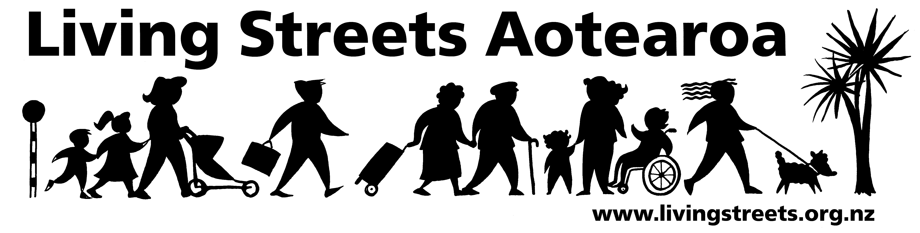

Submission from Living Streets Wellington
Porirua Transportation Strategy

Contact person: Ellen Blake
Email: ellebla@paradise.net.nz
Phone 021 106 7139
Date: 31 May 2011

About Living Streets

Living Streets Aotearoa is New Zealand’s national walking and pedestrian organisation, providing a positive voice for people on foot and working to promote walking friendly planning and development around the country. Our vision is “More people choosing to walk more often and enjoying public places”.

The objectives of Living Streets Aotearoa are:
- to promote walking as a healthy, environmentally-friendly and universal means of transport and recreation
- to promote the social and economic benefits of pedestrian-friendly communities
- to work for improved access and conditions for walkers, pedestrians and runners including walking surfaces, traffic flows, speed and safety
- to advocate for greater representation of pedestrian concerns in national, regional and urban land use and transport planning.

Wellington is the local walking action group based in this area which is working to make city and suburban centres in the region more walking-friendly.

For more information, please see: www.livingstreets.org.nz

Submission
Living Streets Wellington strongly supports the walking strategies, and because of the close links between walking and public transportation supports the public transport objectives.

We strongly support initiatives with schools to encourage walking to school such as the ‘walking school bus’ and school travel plans initiatives.
While walking and cycling are both active modes of transport they do require different infrastructure to accommodate all types of pedestrian and should be considered separately if increasing rates of walking are a serious objective. For example, using footpaths as an easy or cheap route for cyclists will inevitably lead to less pedestrians. Pedestrians and cyclists have different characteristics; while all people are pedestrians a much smaller subset are cyclists, and it is noted that there is also low access to private vehicles in some areas. We urge the council to identify pedestrian characteristics separately and form initiatives tailored to suit pedestrians which could be part of the 3 yearly audits.

One action would be to adopt the NZTA Pedestrian Planning and Design Guide as the minimum standard for footpath construction.

Council support for Walk2Work day in March each year should be part of this strategy, as a means to highlight and encourage the fun and ease of use aspects of walking every day.

We would like to make an oral submission on this plan if there is opportunity for it.

