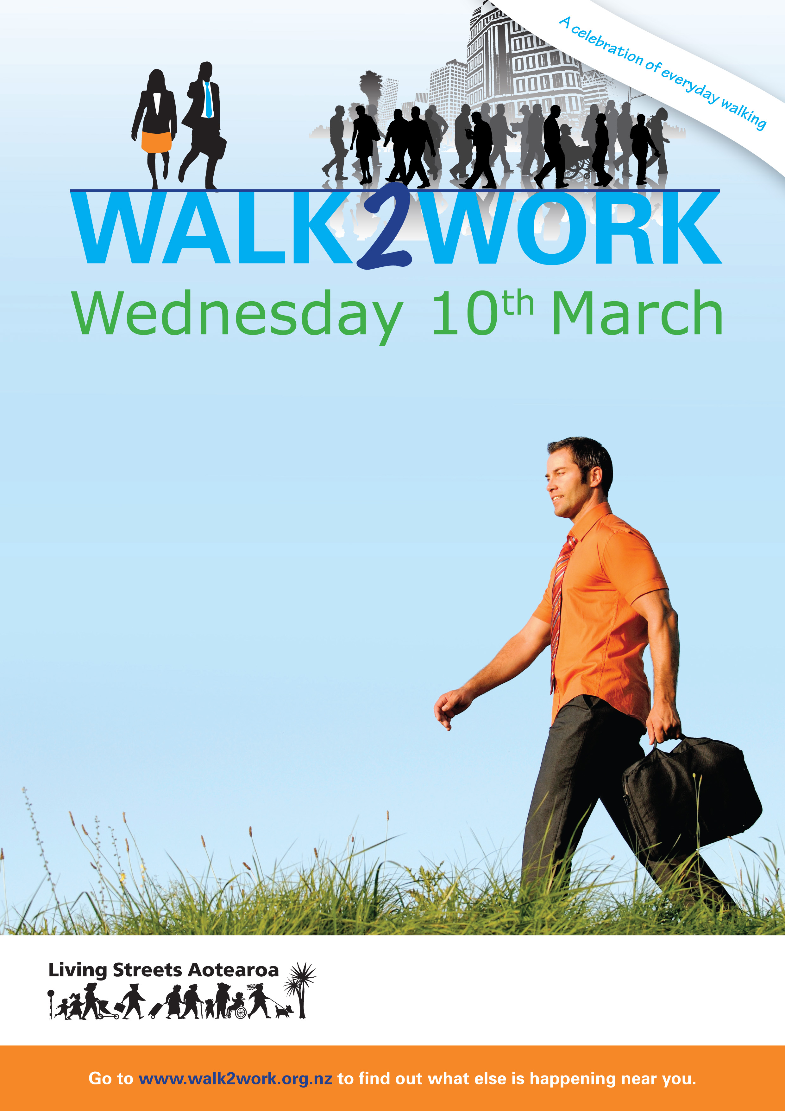
Competitions
Free breakfast events
Stories
And much more

