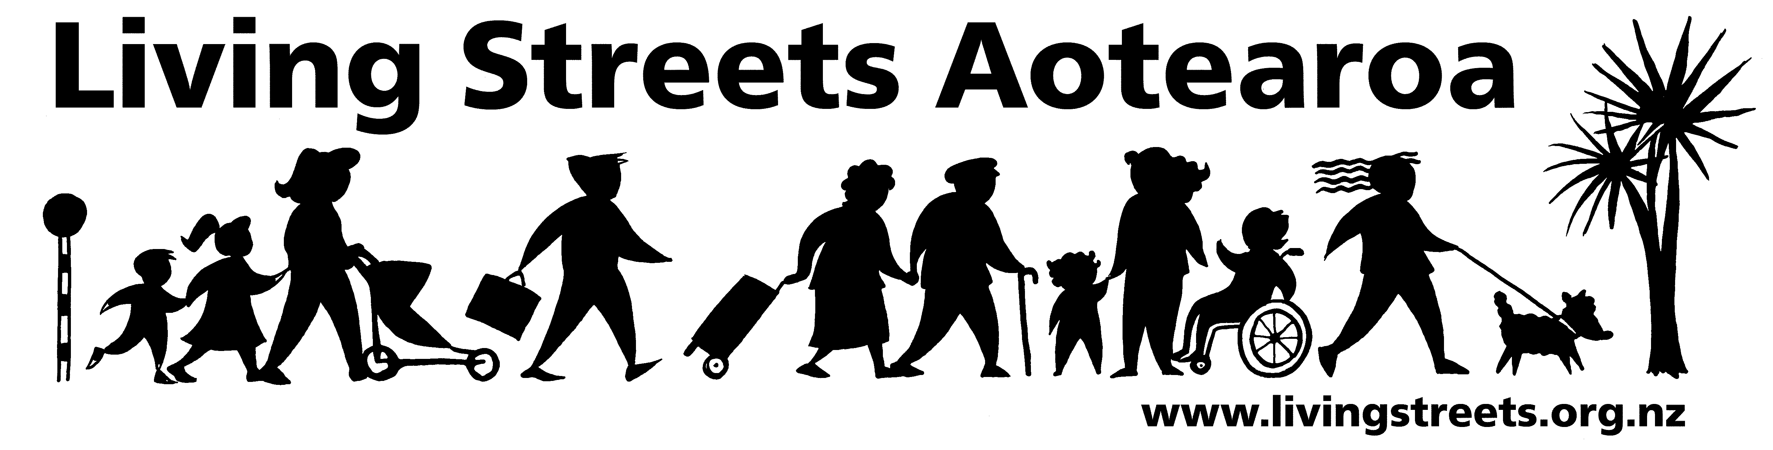

Submission from Living Streets Wellington
Greater Wellington annual plan

Contact person: Ellen Blake
Email: ellebla@paradise.net.nz
Phone 021 106 7139
Date: 27 April 2011

About Living Streets

Living Streets Aotearoa is New Zealand’s national walking and pedestrian organisation, providing a positive voice for people on foot and working to promote walking friendly planning and development around the country. Our vision is “More people choosing to walk more often and enjoying public places”.

The objectives of Living Streets Aotearoa are:
- to promote walking as a healthy, environmentally-friendly and universal means of transport and recreation
- to promote the social and economic benefits of pedestrian-friendly communities
- to work for improved access and conditions for walkers, pedestrians and runners including walking surfaces, traffic flows, speed and safety
- to advocate for greater representation of pedestrian concerns in national, regional and urban land use and transport planning.

Wellington is the local walking action group based in this area which is working to make city and suburban centres in the region more walking-friendly.

For more information, please see: www.livingstreets.org.nz

Submission
Living Streets Wellington supports the funding of school travel plans and urges that this is extended to more schools to support walking as an important mode of travel for tomorrow’s adults. The funding levels in the LTCCP should be maintained and not reduced.

We support the further development and promotion of the walking journey planner.
The annual plan is vague on what walking initiatives or facilities are being funded. For instance, on page 29 capital expenditure funding is provided for pedestrian facilities – what are they? More work is required on the interface between public transport and walking, to ensure that both complement and enhance the other. For instance, bus priority needs to be compatible with pedestrian movement in the CBD. Work is required on how this can best happen.

We would prefer funding for advice on safe driving/riding as a focus rather than safe walking. Walking is inherently safe apart from the vehicles encountered.

What does ‘continue working with the Ministry of Transport and the bus industry to develop a new procurement model for services consistent with MoT objectives’ mean? Services should be bought to meet the community needs.

We would like to make an oral submission on this plan if there is opportunity for it.

