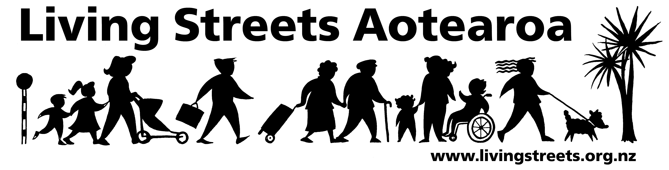

Submission from Living Streets Wellington
Traffic Resolution 101-11 Shared path in Tawa along Luckie, Beauchamp and McLellan Streets
Contact person:
Email:
Phone
Date: 4 November 2011

About Living Streets

Living Streets Aotearoa is New Zealand’s national walking and pedestrian organisation, providing a positive voice for people on foot and working to promote walking friendly planning and development around the country. Our vision is “More people choosing to walk more often and enjoying public places”.

The objectives of Living Streets Aotearoa are:
- to promote walking as a healthy, environmentally-friendly and universal means of transport and recreation
- to promote the social and economic benefits of pedestrian-friendly communities
- to work for improved access and conditions for walkers, pedestrians and runners including walking surfaces, traffic flows, speed and safety
- to advocate for greater representation of pedestrian concerns in national, regional and urban land use and transport planning.

Wellington is the local walking action group based in this area which is working to make city and suburban centres in the region more walking-friendly.

For more information, please see: www.livingstreets.org.nz

Submission
In general we do not support the the creation of ‘shared paths’ because of the following issues:
-
- cycles on footpaths reduce the amenity of footpaths and discourage walking
- transfer of cycle problems from the road where they are legally entitled to be to the footpath encourages cyclists to believe they can use footpaths in all areas, as is demonstrated by the number of cyclists on footpaths, even in the CBD
- cycles on footpaths decrease safety for pedestrians and increase rates of accidents
- existing ‘shared paths’ look exactly like footpaths (and often have only been ‘renamed’) encouraging vehicle users to ride and park on them. Shared paths are not the solution to the cycle problem and transfer problems to pedestrians.
- experience shows that cyclists do not give way to pedestrians
- it is unclear what road rules apply to ‘shared areas’ or footpaths, particularly what speed limit
- there appears to be little enforcement by either the council or police of vehicle users on footpaths or ‘shared areas’

We submit that these areas need to be addressed whenever shared paths are considered in general, and specifically in this case. We note that the discussion in the proposed Traffic Resolution focusses entirely on cyclists, with no mention of the pedestrians who will be sharing the facility, and may well constitute the majority of users.
We wish to be heard in support of our submission.

