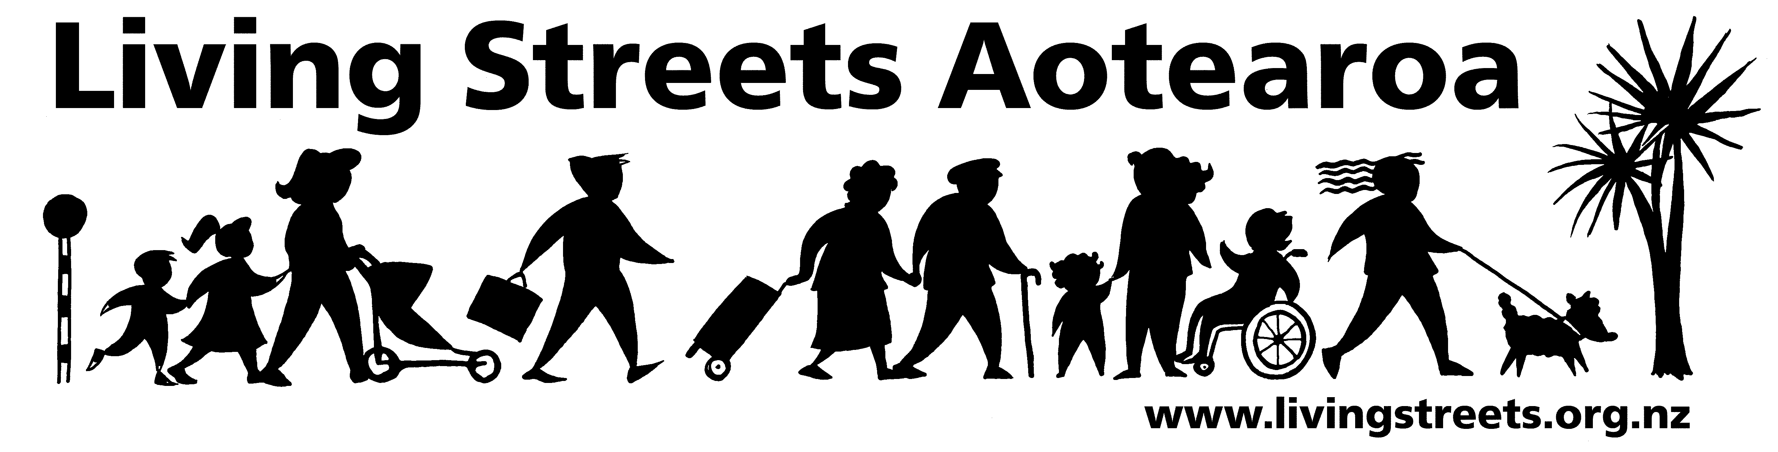

Submission from Living Streets Aotearoa

Contact person: Ellen Blake
Email: wellington@livingstreets.org.nz
Phone: 021 106 7139
Date: 15 May 2013

About Living Streets

Living Streets Aotearoa is New Zealand’s national walking and pedestrian organisation, providing a positive voice for people on foot and working to promote walking friendly planning and development around the country. Our vision is “More people choosing to walk more often and enjoying public places”.

The objectives of Living Streets Aotearoa are:
- to promote walking as a healthy, environmentally-friendly and universal means of transport and recreation
- to promote the social and economic benefits of pedestrian-friendly communities
- to work for improved access and conditions for walkers, pedestrians and runners including walking surfaces, traffic flows, speed and safety
- to advocate for greater representation of pedestrian concerns in national, regional and urban land use and transport planning.

Wellington is the local walking action group based in this area which is working to make city and suburban centres in the region more walking-friendly.
For more information, please see: www.livingstreets.org.nz

Submission
We support the Council’s vision Towards 2040 – Smart Capital of a city that is people centred, connected, and a dynamic eco city.

We support the Councils’ smart energy initiatives to reduce climate change impacts, the greening of Taranaki St to provide pedestrian comfort through landscaping, the Miramar development framework that will enhance pedestrian activity, and a reduction in speed limits in the CBD.

However we are disappointed in the low level of support given to pedestrians and public transport users in this annual plan despite being identified as a significant component in the Wellington transport system.

Wellington waterfront development
We support development of ‘the Promenade’ route to the Railway Station. We have previously written to the council about the poor pedestrian links from the station to the waterfront and would hope to see some of those suggestions implemented.

We support the Frank Kitts children’s playground upgrade and hope to see safety improved by removing cars and parking from the area immediately adjacent to it.

We do not support funding for Crocodile bike parking. These large vehicles should not be allowed on footpaths (currently their base is situated on footpath) and use of them should be totally reviewed as more of these recreational vehicles are appearing on our footpaths.

Urban planning
It is encouraging that the council has a vision for Wellington built on a human scale – walking is the transport mode at human speed.

We support the project for the Memorial Park as long as the key pedestrian routes along Tasman/Tory Streets, Buckle St are maintained, and existing footpaths remain pedestrian only. There is some urgency to re-establish the pedestrian link along Tasman-Tory St as the temporary arrangements are unsatisfactory.

Transport
The preamble to the plan states that Wellingtonians have a high use of public transport and also walk more than other cities yet there are no major projects to support these transport modes and few pedestrian-promoting activities at all.

We note there is a high proportion of Wellingtonians walking at 22% and would like to see an actual target for improving this statistic so that some effort is made to do this. We suggest a 25% walking indicator is achievable. Similarly for children walking to school and use of public transport, an target indicator increasing use is desirable. The peak travel time (I assume is for cars) and is not a suitable indicator for an eco-city. Similarly it is disturbing to see an expected 4 pedestrian deaths included in this plan. We note there is no pedestrian satisfaction indicator as there are for other transport modes.

We support the addition of fences and guardrails where there is a drop of more than 1 metre on a footpath in line with the Pedestrian Planning and Design Guide adopted by Council.

We have previously objected to the Tawa shared path project as only benefiting cyclists and note, the more vehicles on paths the less pedestrians will use them.

The only project likely to benefit pedestrians in suburban areas, although this isn’t explicit in the annual plan, is the Miramar development, and we support this on that understanding.

Budget
It is difficult to identify what the $6,292,000 pedestrian network expenditure is for, or the $5,375,000 capital expenditure, although we note some will be used for the fences and guard-rails provision and there is $523,000 allocated on walkways presumably in parks.

There are more projects (3) to promote car parking than for pedestrians (0) – this is not an eco-city vision that we can share. The financial strategy supports fairness and equity, value for money and city resilience all of which can be achieved through supporting pedestrian projects.

We look forward to working with the council to achieve the annual plan projects.

I wish to be heard in support of this submission.

